**A3: Low-Fidelity Prototyping with Heuristic Evaluation**

**Group 10: Magdalen, Maya, Soyun, Leslie**

**Brainstorming Session**

**Describe how you grouped the ideas and selected the most promising idea**

**Step 1 - Developing a POV**

The first step in our brainstorming session was to develop point of view (POV) statements. During this section, we first described our users as students at UVIC. Next, we detailed the needs of our users pertaining to our project, which we determined to be firstly, the need to deeply understand class material in order to answer complex questions and create condensed notes for exam preparation. Secondly, we identified the need to quickly memorize differences between key concepts and understand how to apply them (O'Leary, Wobbrock, & Riskin, 2013).

Then we brainstormed insights, which uncover the deeper motivation behind the user's needs. The first insight we brainstormed was that the user requires a system to input current class notes and receive condensed notes retaining essential information. Additionally, a feature guiding users through notes would aid in comprehension and familiarity with the note structure. For exam preparation, users would benefit from practice questions, particularly case studies resembling those in their textbooks. To facilitate this, the system should allow users to input example case studies and generate novel yet similar questions or case studies.

The second insight we brainstormed is that the user must grasp various textbook chapters before exams, needing both basic understanding and clarity in potentially confusing sections. In conclusions, creating these POV statements was important because they offered us valuable insights into user experiences, behaviors and key challenges (O'Leary, Wobbrock, & Riskin, 2013).

Table 1: The table of the POV statements we generated in our brainstorming session

| User | Need | Insight |
| --- | --- | --- |
| Undergraduate law student | Deeply understand class material to be able to answer complex questions and create condensed notes to bring into exam | The user will need to be able to input current notes from class and have an output of condensed notes that still contains all vital information. Would be useful to also have a component that walks through the notes with the user, so they can refresh understanding of material and become familiar with the note structure.   To prepare fore exam, user would benefit from practice questions that are similar to those in their textbook (case studies). To accomplish this, they would need to be able to input example case studies (upload part of textbook/instructor material) and have novel, but similar, questions/case studies, created. |
| UVic Undergraduate Sociology student | Quickly memorize differences between key concepts and understand how to apply them | The user needs to understand numerous chapters from their textbook before completing assignments or exams. Not only will this require them to already have a basic understanding of the material to understand more advanced topics, but the textbook they are studying from may quickly become confusing, assuming the reader already understands certain concepts. |

**Step 2 - Making How We Might Questions**

The next step was to develop "how might we" (HMW) questions for our project. To achieve this, we collectively discussed the features we desired to see implemented in our final design and distilled them into the questions seen below.

1. How might we design an interface that allows students to use different study methods for example mindmaps, flashcards etc after inputting their material.
2. How might we create an interface where the student can upload notes and they are processed by an AI Large Language Model and condensed effectively. How might we make this iterable, so students can refine the created notes if it doesn’t contain the information they need.
3. How might we allow students or teachers to upload class material relevant to exam and have the study planner create relevant questions for the exam
4. How might we have an interface where students can interactively answer practice questions one at a time and receive feedback on questions that is accurate and helpful
5. How might we integrate the study planner into brightspace so it contains the information from all class material uploaded to brightspace automatically

**Step 3 - Individual Ideas**

During this stage, we engaged in a group discussion where we each shared various ideas without delving into detailed discussions. The primary goal was to generate as many ideas as possible, encouraging creativity and differing perspectives.

**Step 4 - Individual Sketches**

After exploring "how might we" questions and generating additional ideas, we moved on to creating individual sketches envisioning our final interface design. We then shared these sketches with each other and engaged in detailed discussions to identify which designs showed the most promise.

**Step 5 - Combined and Narrowing Down ideas**

During the subsequent lab session, we shared our sketches and collectively decided which aspects of each team member's design to incorporate into the final design. To make these decisions, we utilized the affinity diagramming method, clustering our ideas together and discussing the connections and overlaps between them to determine which ideas were worth pursuing (Lucero, 2015) . Additionally, we employed the voting method for some designs, where if the majority agreed to keep a particular design, we would retain it.

**Describe the related works you considered during the discussion and list what you think are the key differences between your idea and existing works.** 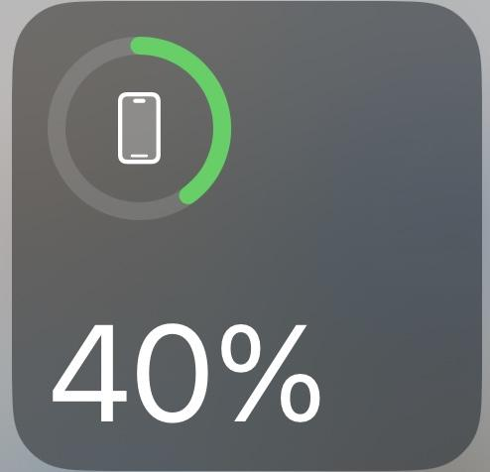

During the design process, we employed idea finding methods to develop our ideas for the project. For instance, when designing the study completion bars on the main page (Figure 3), we examined examples showcasing well-designed progress bars. Using the SCAMPER method, we chose to adapt the Apple UI (seen in the image to the right) for our project. Additionally, we gathered examples from existing systems; for instance, we analyzed Quizlet and GoodNotes flashcard systems, then combined and modified them to design the flashcard system depicted in Figure 7. One notable difference between our idea and existing works is the integration with learning platforms commonly used at universities. This integration allows users to easily access and share study materials with other students. For instance, while platforms like Quizlet may offer study sets for your class, they may be outdated, representing material from a different academic year.

**Reflect on the process – what worked, what was difficult, and what would you change next time**

For what worked, we found that the sketches provided a clear direction for our design. However, deciding which features to include or exclude posed a challenge. In hindsight, we might consider testing storyboarding for various tasks to gain deeper insights into potential user interactions with the software.

**Sketches**

**Selected Sketches Explanation**

Among the sketches, we selected Figure 1, Figure 2, Figure 3, Figure 5, Figure 11, Figure 12, and Figure 15/7. The explanations of these selections are as follows:

* **Figure 1**: Shows the "expand your knowledge" section aimed at helping students delve deeper into their topics, providing additional information about a particular topic.
* **Figure 2:** Shows the available study methods.
* **Figure 3**: Depicts the home page featuring classes, study progress bars, and the option to select a class for studying.
* **Figure 5:** Represents a section where users can create mind maps to organize their thoughts and ideas.
* **Figure 11:** Presents an AI-generated list of key concepts, aiding users in quickly memorizing differences between concepts and providing relevant examples. It also references equivalent sections from the course textbook for further information and allows exporting to the "Flashcards" or "Quiz" study tools.
* **Figure 12:** Illustrates a class database in a board style, enabling users to freely upload study materials and share them for the course, with the option to post publicly or anonymously.
* **Figure 15 and 7:** Displays a potential homepage layout and navigation to the cue card study tool.

**Magdalen’s Sketches**

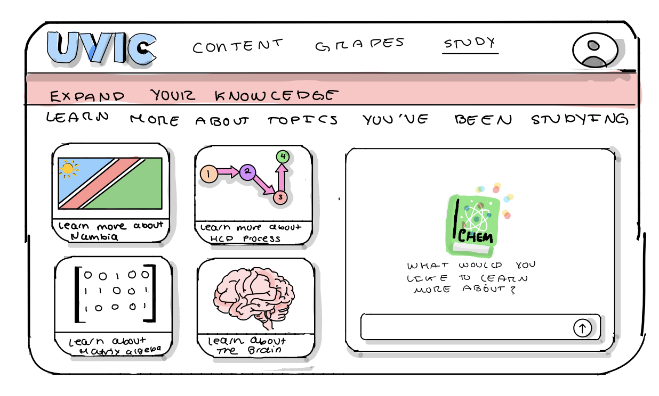

Figure 1.

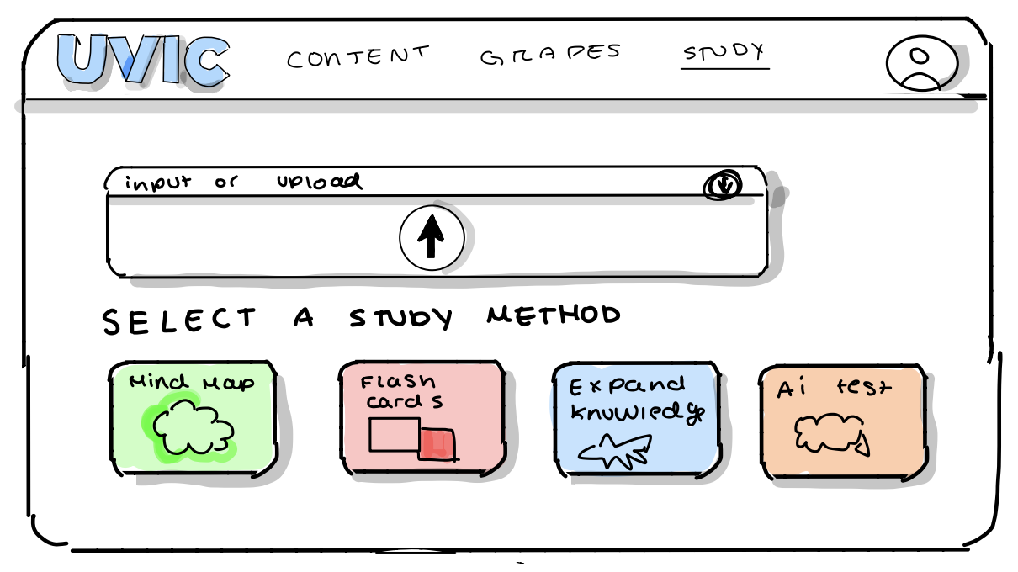

Figure 2.

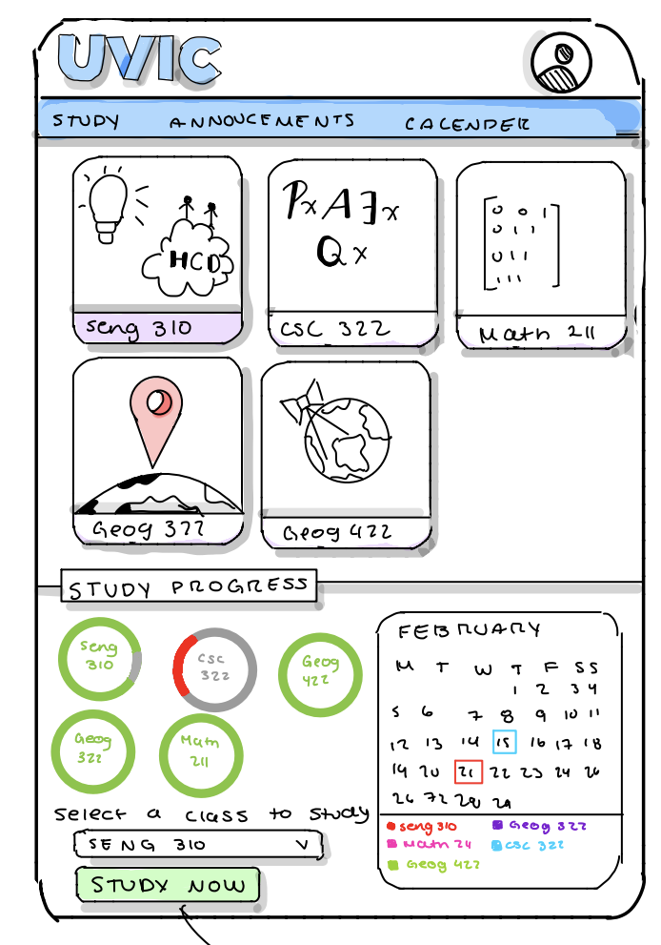

Figure 3.

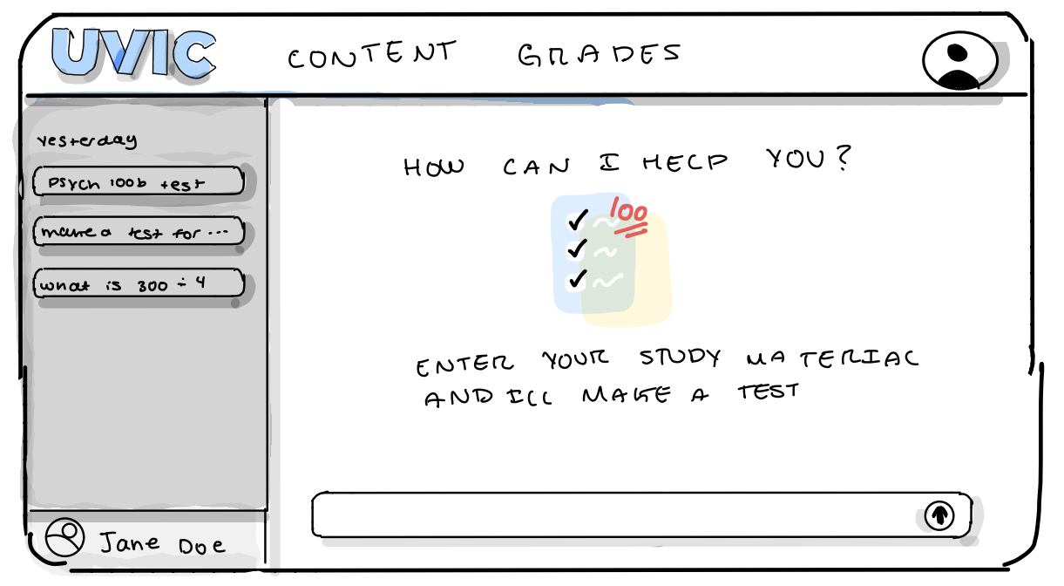

Figure 4.

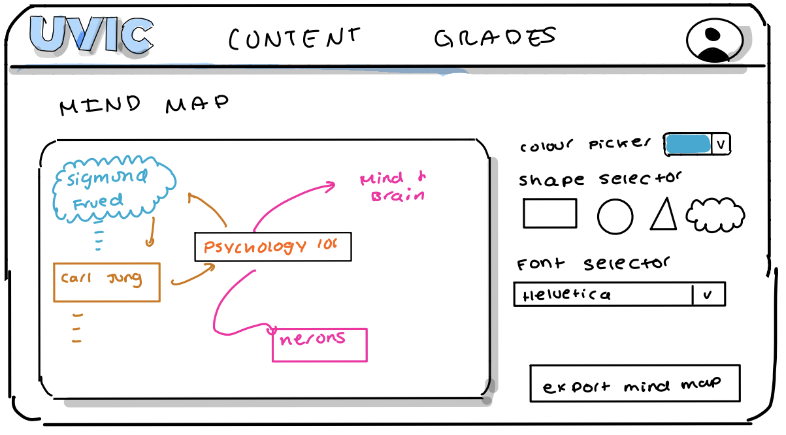

Figure 5.

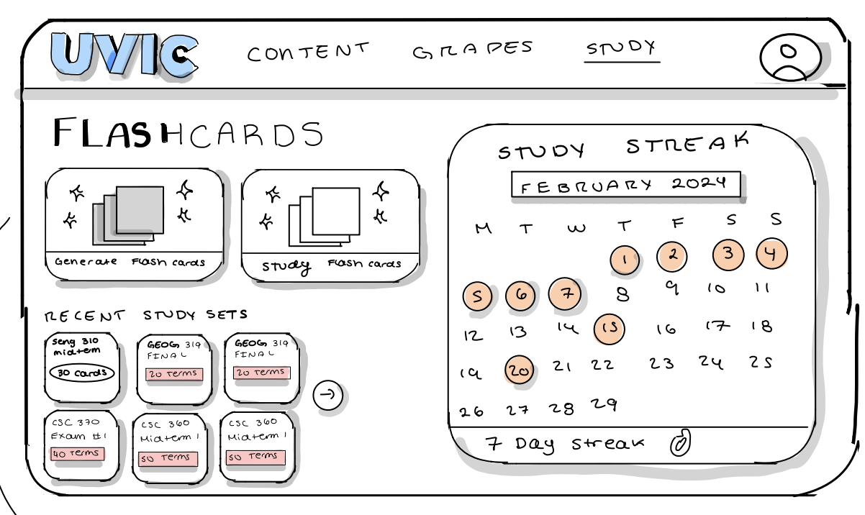

Figure 6.

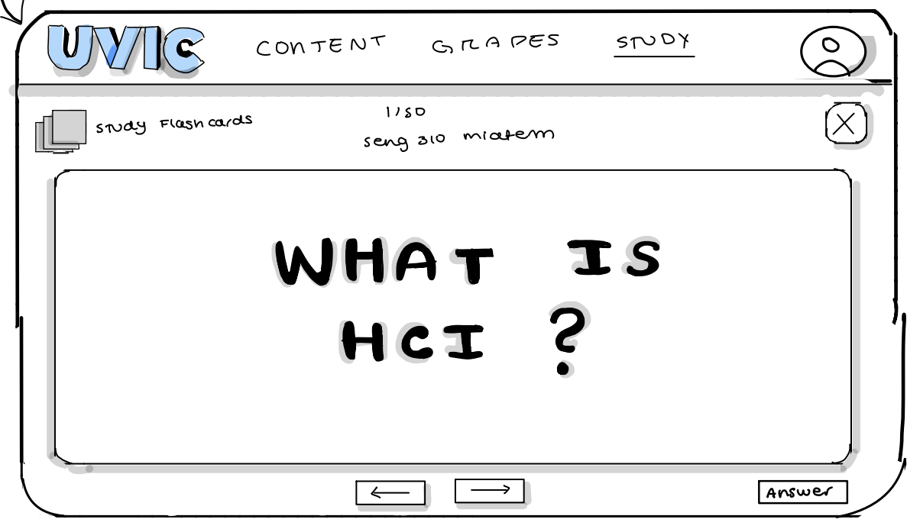

Figure 7.

**Soyun’s Sketches**

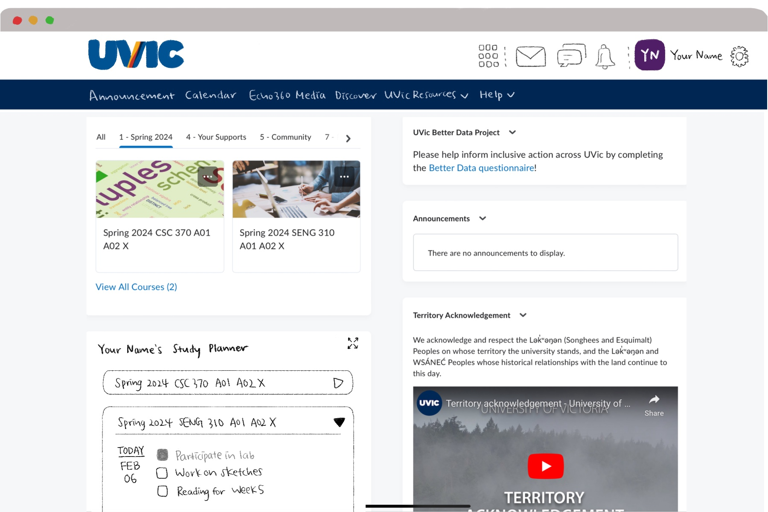

Figure 8.

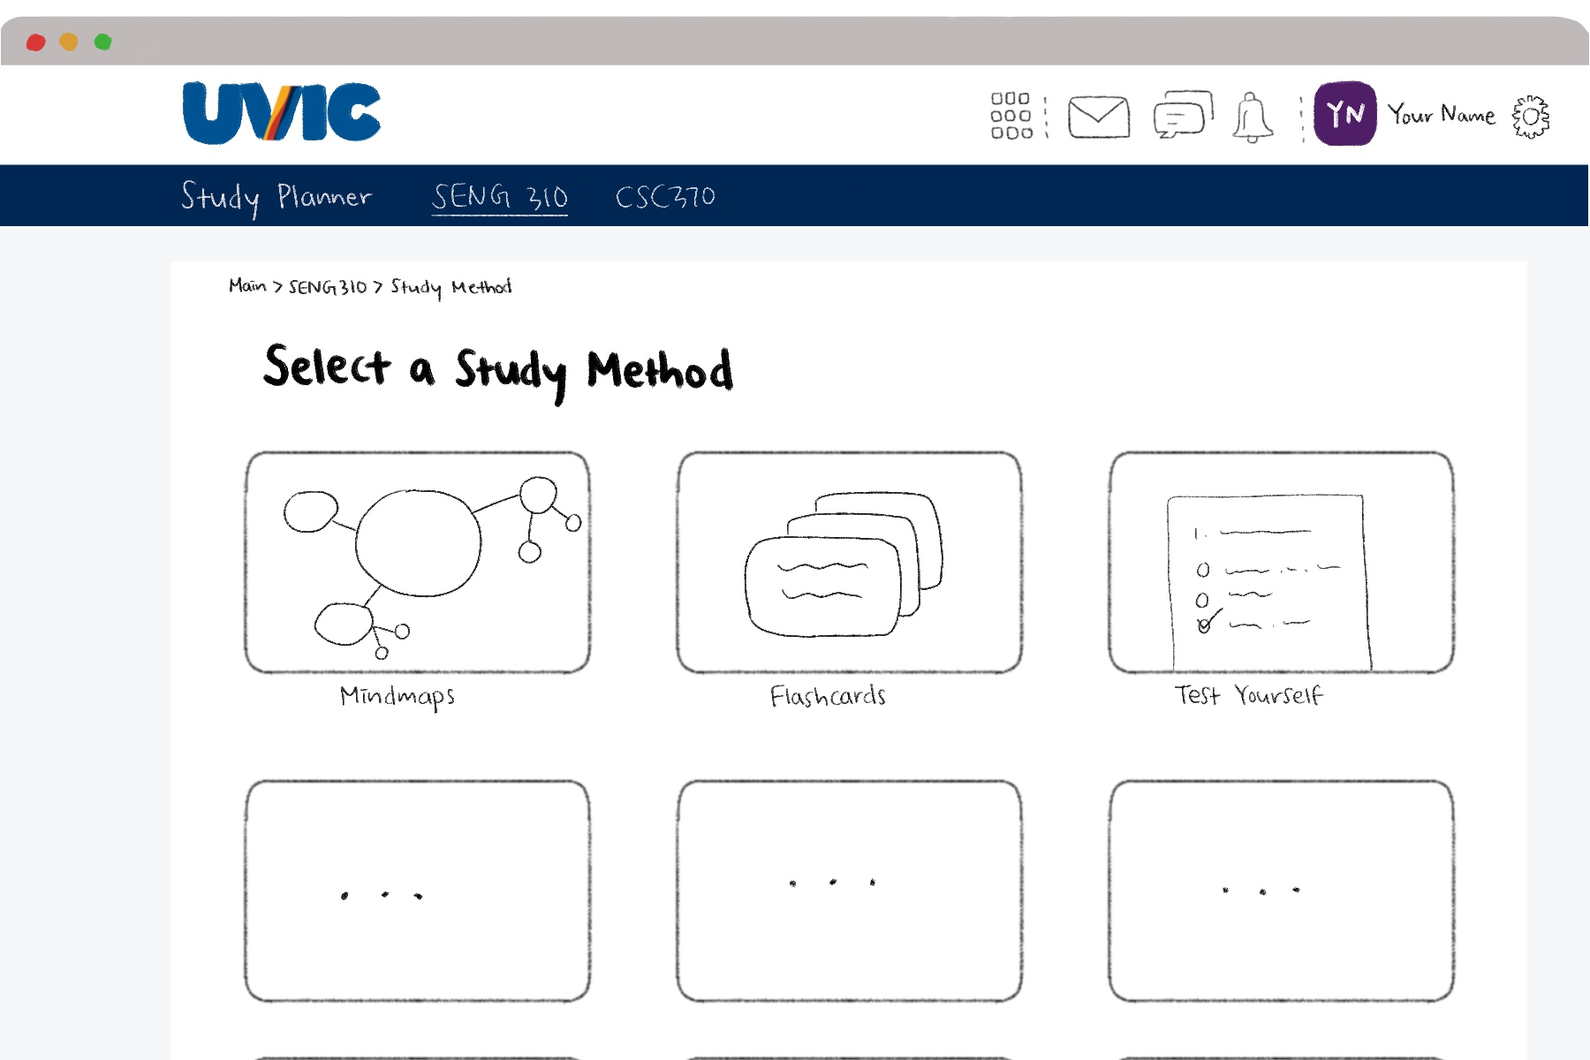

Figure 9.

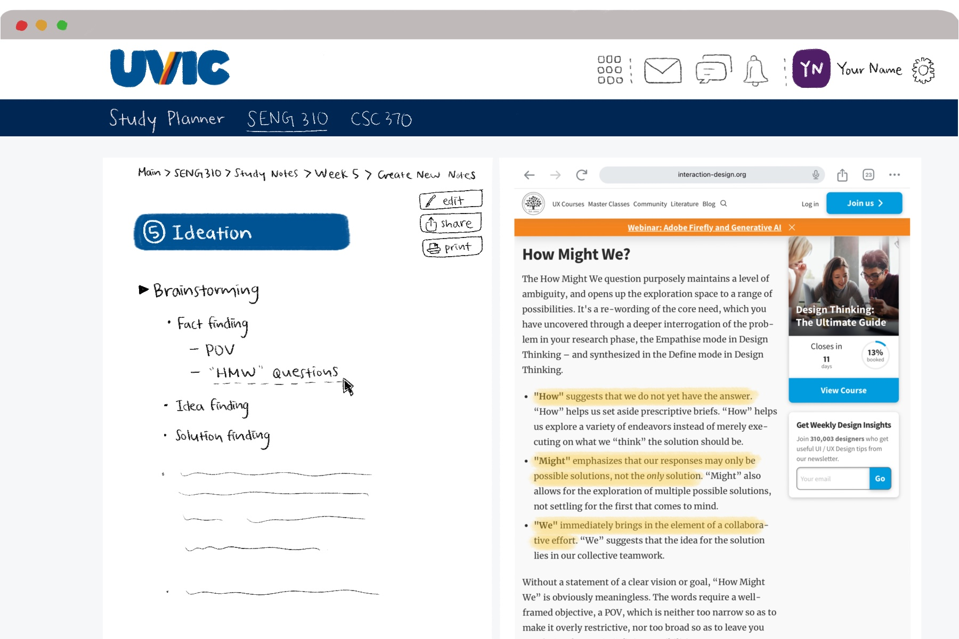

Figure 10.

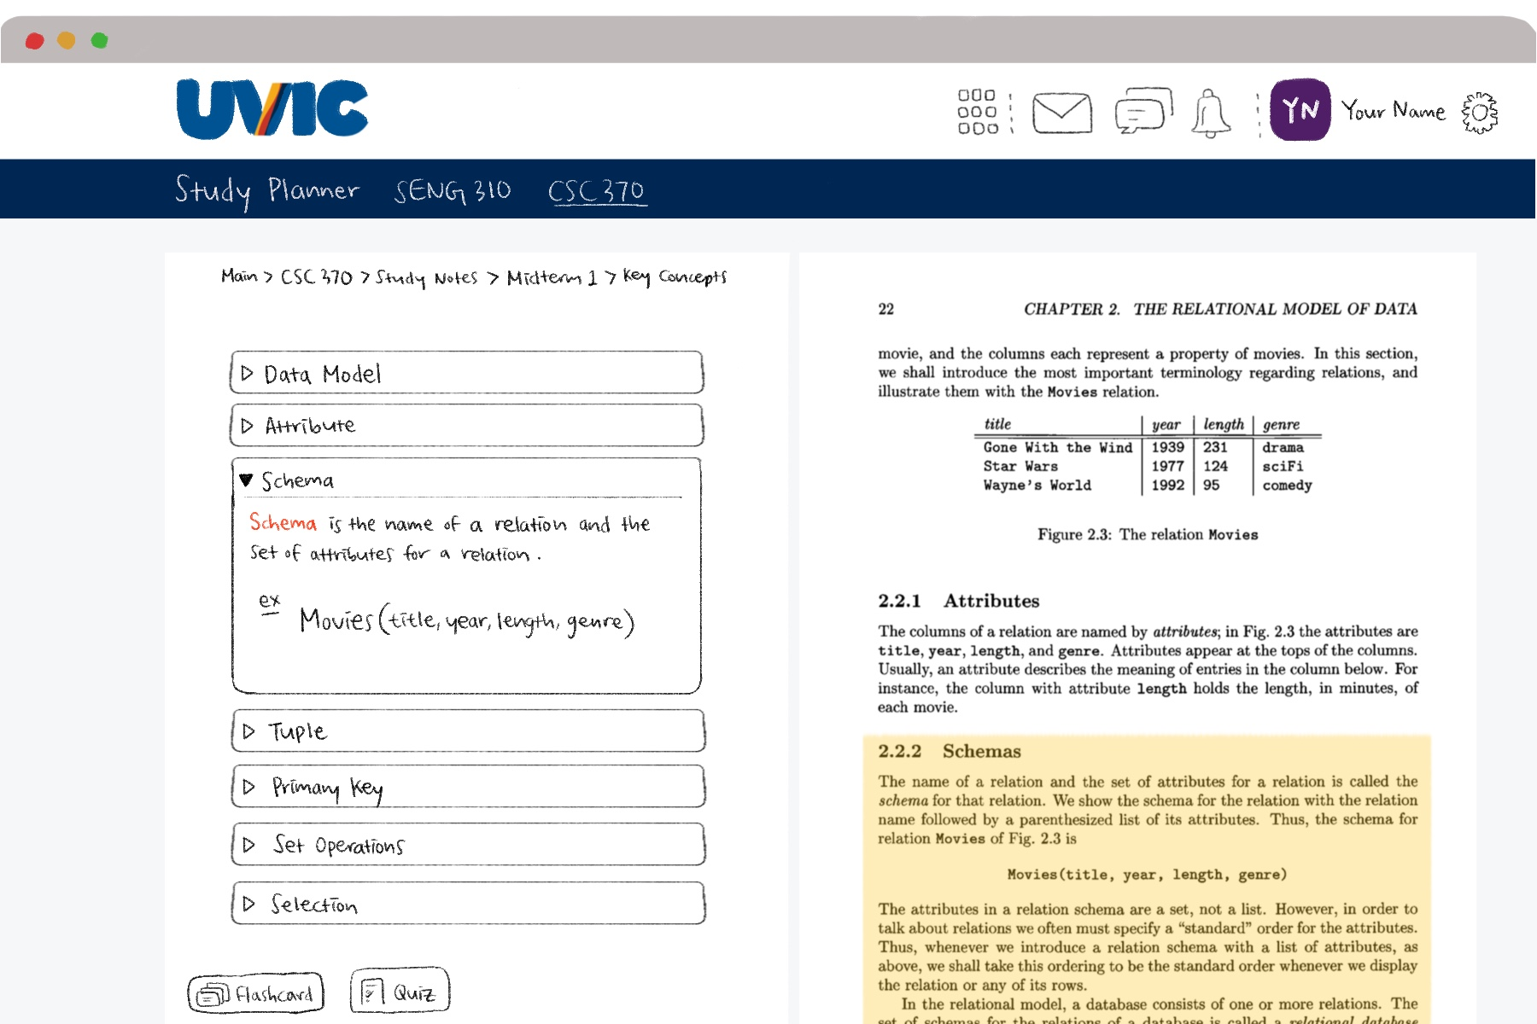

Figure 11.

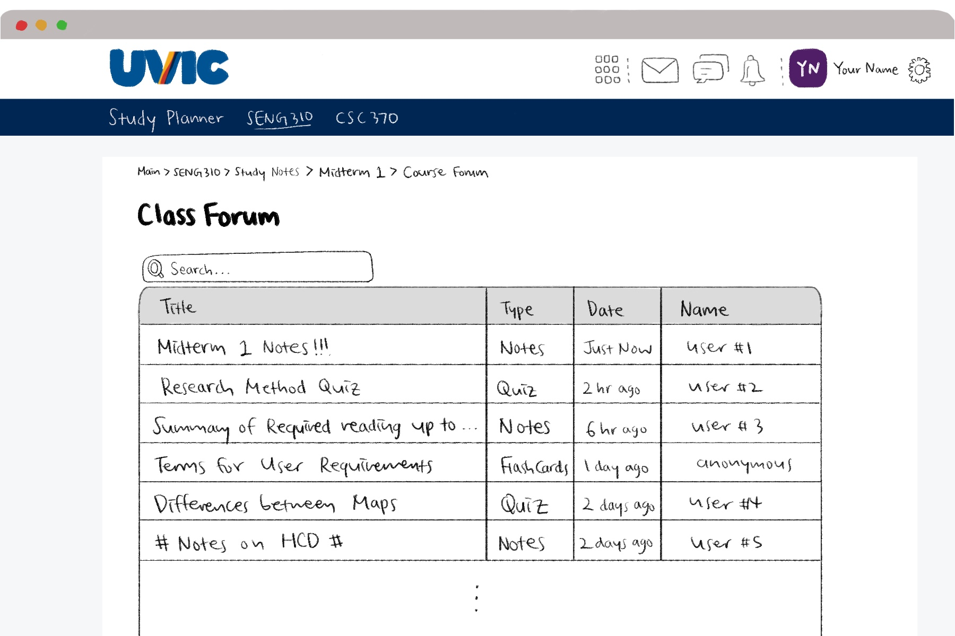

Figure 12.

**Maya’s Sketches**

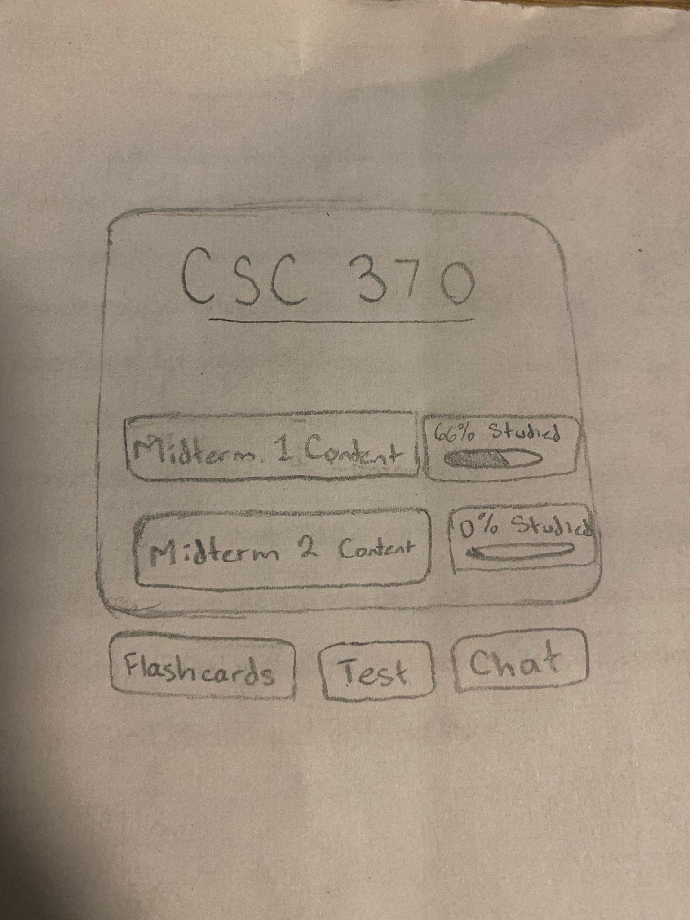

Figure 13.

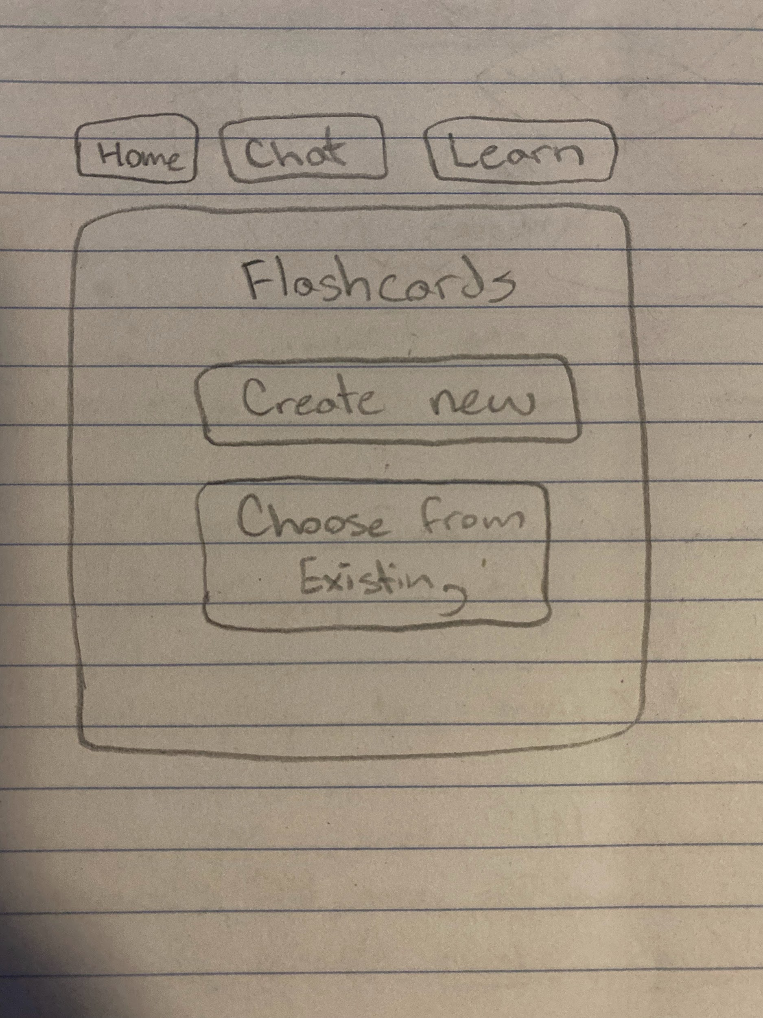

Figure 14.

**Leslie’s Sketches**

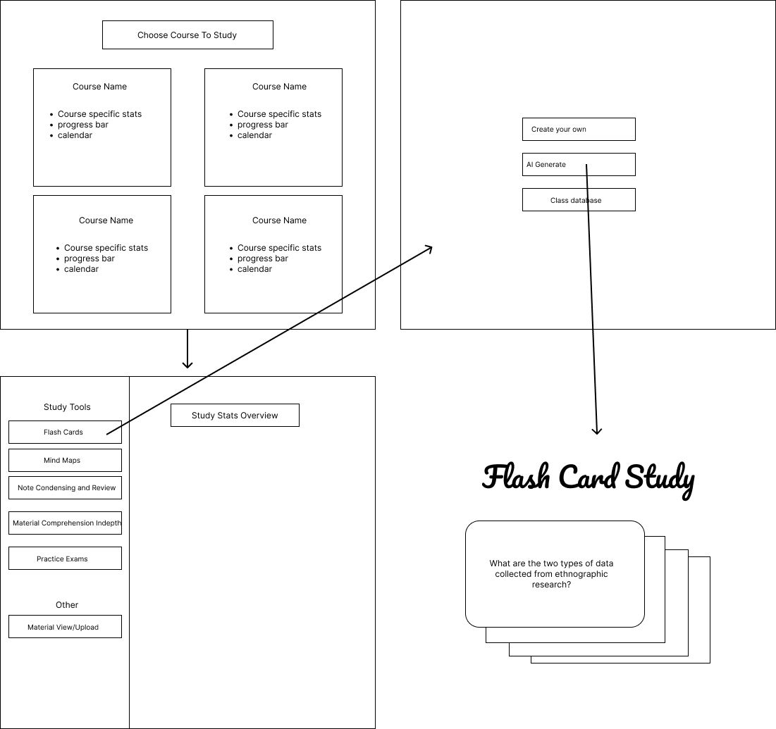

Figure 15.

**Heuristic Evaluation**

Utilizing Nielsen’s 10 usability heuristics, we conducted a heuristic evaluation to identify any design issues within the interface of our video prototype. Initially, we focused our assessment on specific sections and features depicted in the video. Each team member conducted individual evaluations (Table 1), assigning severity ratings on a scale of 0 to 4, where 0 indicates no usability issues and 4 signifies a usability catastrophe. Subsequently, we consolidated the identified issues and discussed potential development strategies. To summarize, our interface evaluation revealed several key insights. Overall, we found that our interface successfully adheres to Nielsen's usability heuristics in terms of matching the system with the real world, prioritizing recognition over recall, and integrating flexibility and efficiency of use within BrightSpace, resulting in a self-explanatory design. However, we identified deficiencies in user control and freedom, as well as error prevention, which require immediate attention and should be addressed as high-priority issues. A detailed reflection follows in the subsequent paragraph.

Our heuristic evaluation allowed us to properly reflect on our interface, and revealed areas which were particularly well implemented. Because our solution is intended to be implemented within Brightspace, we were all able to agree that our interface was efficient, easy to use, and was consistent with the existing platform Brightspace, making it easy for users to recognize and navigate through the familiar layout. Our interface was able to take the aspects of Brightspace which are already known to be effective, and simply add onto them. Our new features still need a bit of work to allow us to maximize their potential, but the prototype has allowed us to see that much of our work so far is functioning as desired.

Our evaluation also revealed that there were some areas which definitely needed improvements, especially in regards to user control and freedom, consistency between each study tool, and error prevention. For user control and freedom, it was clear that there needed to be more options for the user to undo, edit, and exit their study plan session or particular task they are working on. The need for proper error prevention was also emphasized by our evaluation, as our current interface does not properly take into account proper error handling. Although this prototype was less likely to have severe usability errors, they are more likely to occur as we continue to implement all of our design requirements, particularly once our design starts utilizing artificial intelligence.

In the future, we agreed that we would need to emphasize user control and freedom, as this will not only prevent errors and allow users to go back in the event of a mistake or slip, but also give them a sense of security when using our interface, as none of their actions would be set in stone when creating or modifying a study set. Another thing we would have done differently when designing our prototype would be simply taking heuristics into account during the design process, as we did not include any kind of help or documentation initially, which turned out to be a fairly important aspect as many users may need some extra assistance to fully utilize certain features.

Table 2. Result of the Heuristic Evaluation based on video prototype

| Heuristic Evaluation | | | | | | | | | | | |
| --- | --- | --- | --- | --- | --- | --- | --- | --- | --- | --- | --- |
| Heuristics for Usability | | Name | | Severity ratings and brief reasoning | | | | | | | |
| 1 Visibility of system status | | Soyun | | 1 - could display the selected course/study focus (in a breadcrumbs bar, for example) to inform the user of the current selection | | | | | | | |
| Maya | | 0 | | | | | | | |
| Magdalen | | 0 - System status isn't necessary for a calender | | | | | | | |
| Leslie | | 2-lacks a loading indicator for AI responses | | | | | | | |
| 2 Match between system and the real world | | Soyun | | 0 - has a similar layout and options to the current LMS | | | | | | | |
| Maya | | 0 - implemented with existing software | | | | | | | |
| Magdalen | | 0 - Similar to Brightspace | | | | | | | |
| Leslie | | 0 | | | | | | | |
| 3 User control and freedom | | Soyun | | 3 - does not support users to undo their selection or go back to the previous selection, etc. | | | | | | | |
| Maya | | 0 - easy to navigate, gives users freedom to decide which feature they want to use | | | | | | | |
| Magdalen | | 3 - needs some king of undo and redo functionality especially when it comes to creating study materials. | | | | | | | |
| Leslie | | 3- Needs additional functionality to allow for re-creating/editing study plan/study session. Could be more convenient to be able to change study focus when you are within a study tool instead of choosing ahead of time | | | | | | | |
| 4 Consistency and standards | | Soyun | | 0 - the layout is similar (i.e. the sidebar is on the left) | | | | | | | |
| Maya | | 2 - design could be simplified and used almost universally across the whole thing | | | | | | | |
| Magdalen | | 2 - design could be more consistent across different study methods | | | | | | | |
| Leslie | | 2- The “choose study focus” sidebar hierarchy could be simplified so that all the options under each study focus is visible and there is a different way to choose study focus (maybe always visible on a top bar), with the closest upcoming task (midterm/assignment) automatically selected when course is clicked. | | | | | | | |
| 5 Error prevention | | Soyun | | 3 - does not allow users to navigate back to previous flashcards in the event where the user accidentally double-clicked the card and skipped the content. (could have forward/backward arrow buttons below the flashcard for users to navigate freely) | | | | | | | |
| Maya | | 3 - need to include error prevention for the AI especially, as it is most likely to break out of all features | | | | | | | |
| Magdalen | | 3 - Important to design an error prevention system for all the study methods (flash cards etc) because currently one does not exist. | | | | | | | |
| Leslie | | 4 - needs back button to return to course selection, and a back button within a study tool to return to the course overview page | | | | | | | |
| 6 Recognition rather than recall | | Soyun | | 0 - the interface is pretty straightforward. A progress bar exists for users to recognize where they're currently at, and nothing is required for users to remember | | | | | | | |
| Maya | | 0 - following brightspace, interface is clearly labeled so not hard to navigate | | | | | | | |
| Magdalen | | 0 - Interface is self explanatory, a student at UVIC shouldn't have issues with it | | | | | | | |
| Leslie | | 1 - instead of an open chat to the AI for help, could employ buttons with suggested questions for the AI to help students learn material (such as “give me a hint”). This could help avoid errors where the AI’s response is not useful/inaccurate, as we could curate the communication going to the AI | | | | | | | |
| 7 Flexibility and efficiency of use | | Soyun | | 0 - provides a few options for users to choose a flashcard study method (AI generated, Create Your Own, and Class Database), allowing for various customizations. | | | | | | | |
| Maya | | 0 - simple interface, easy to use without error if the user is already familiar with brightspace | | | | | | | |
| Magdalen | | 0 - The interface is already quite efficient | | | | | | | |
| Leslie | | 1- There could be a faster way to navigate from main course page to a specific study tool, without having to click through the course, then study focus, then study tool menus. | | | | | | | |
| 8 Aesthetic and minimalist design | | Soyun | | 0 - contains all the necessary elements and the visual design focuses on the essentials | | | | | | | |
| Maya | | 1 - may benefit from some minor changes to make the interface more simple | | | | | | | |
| Magdalen | | 1 - The fonts and colours could be more consist with each other for example the flash cards title font could be the same as it is with the rest of the interface | | | | | | | |
| Leslie | | 2- Progress bars need to have an explicit meaning that is useful/motivating and easy to understand | | | | | | | |
| 9 Help users recognize, diagnose and recover from errors | | Soyun | | 1 - if the prompted response on the flashcard page, for example, is non-interpretable and AI cannot assist, it could display an error message. (Or to prevent this problem, we can include a button for a "hint" instead) | | | | | | | |
| Maya | | 2 - only really concerning with the AI, other places would just have default error messages | | | | | | | |
| Magdalen | | 2 - Could possibly add a prompt before the ‘AI generate’ button to ask users if they want to continue before generation. | | | | | | | |
| Leslie | | 0 | | | | | | | |
| 10 Help and documentation | | Soyun | | 2 - could implement a help button for each study tool to provide a simple tutorial on how to use the tool, what kind of hints AI can give, etc. | | | | | | | |
| Maya | | 1 - could add some help, as not all users may be familiar with brightspace | | | | | | | |
| Magdalen | | 1 - could include a manual or short video tutorial to help people learn how to use the interface | | | | | | | |
| Leslie | | 0 | | | | | | | |

**Storyboard**

With the selected idea, we constructed a storyboard depicting how our persona James from PA2 would interact with our interface for one of our key tasks. The following description illustrates how our interface helps effectively for James to initiate a study session:

As James notices that he has an exam coming up in 3 days on his reminder, he starts using the study planner to effectively plan studying within the given time frame. He sets his daily goal on the planner to reach- studying for two hours, and starts on his first hour-long session. To study more engagingly, James reaches out to his friend, who’s also in the same course, to study together using the built-in study tool in the interface. With a set goal, James feels more motivated to study and experiences a great sense of accomplishment when he completes his study goal.

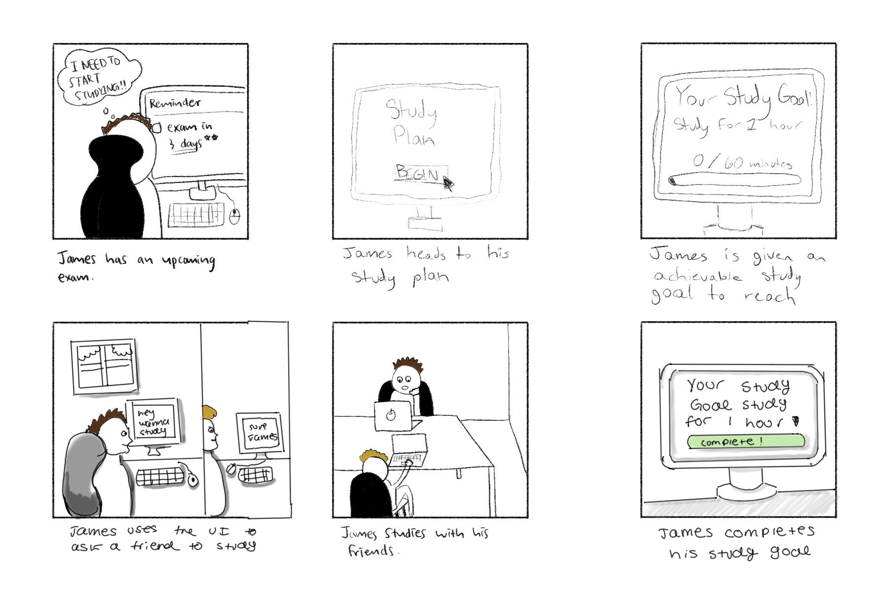

Figure 16. Storyboard for the selected idea depicting a persona interacting with an interface for a key task.

**Video Prototype**

The video prototype illustrates how James could use the AI Study Assistant to help with the task of actively learning and memorizing material. First, he views the homepage of the UVic Brightspace, and then chooses the AI Study Assistant from his course list in the left hand menu. The next task he needs to study for is his second midterm for SENG 310, which is highlighted in the calendar widget on the Study Assistant overview page. He then chooses the SENG 310 course from the sidebar, chooses midterm 2 as his study focus, and then clicks the cue card study tool. Within the cue card study tool, he decides to try out the AI generated cue cards. He doesn’t know the answer to the first cue card and so asks for a hint from the AI assistant. Once given the hint, he thinks he knows the answer, and so clicks the cue card to reveal if his guess is correct.

**Video Prototype Link**

<https://drive.google.com/file/d/12-Psyb5GHyh6UzQMI2guLlOwxzQg3QM5/view?usp=sharing>

References

O'Leary, K., Wobbrock, J. O., & Riskin, E. A. (2013). Q-methodology as a research and design tool for HCI. In CHI '13: Proceedings of the SIGCHI Conference on Human Factors in Computing Systems (pp. 1941–1950). <https://doi.org/10.1145/2470654.2466256>

Lucero, A. (2015). Using Affinity Diagrams to Evaluate Interactive Prototypes. In: Abascal, J., Barbosa, S., Fetter, M., Gross, T., Palanque, P., Winckler, M. (eds) Human-Computer Interaction – INTERACT 2015. INTERACT 2015. Lecture Notes in Computer Science(), vol 9297. Springer, Cham. <https://doi.org/10.1007/978-3-319-22668-2_19>